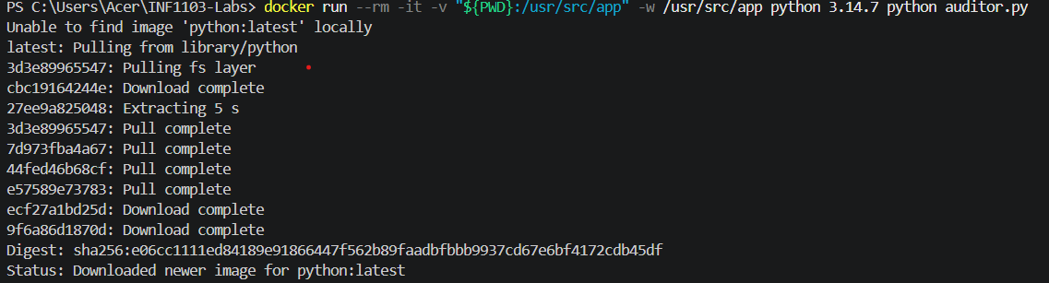
Docker Mount and Run

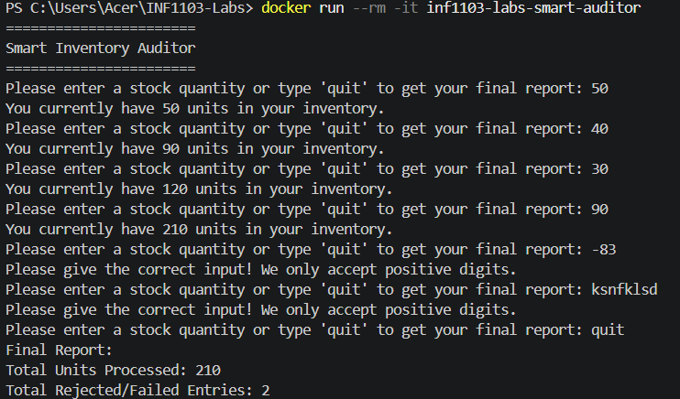

Docker Images
